5.47: This is the same situation as Example 5.22, with the lift force replacing the tension in the string. As in that example, the angle is related to the speed and the turning radius by 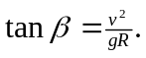 Solving for ,
